Activity 12.3 submission

1. 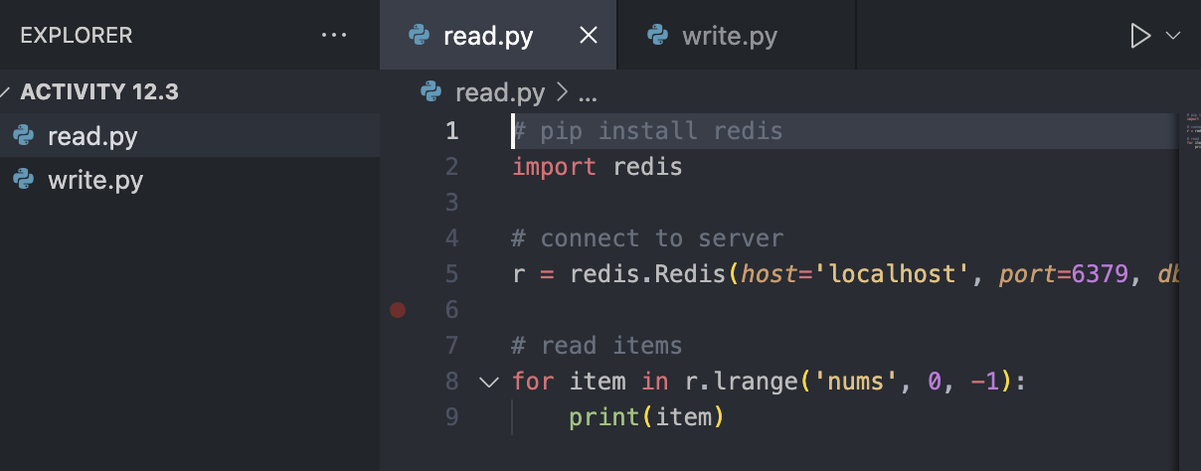
   1. Was able to open the file is VS code
2. Graphical user interface, text, application, chat or text message

   Description automatically generated
   1. Screenshot showing both the successful command and creation of the container as well as the docker container running on the right.
3. 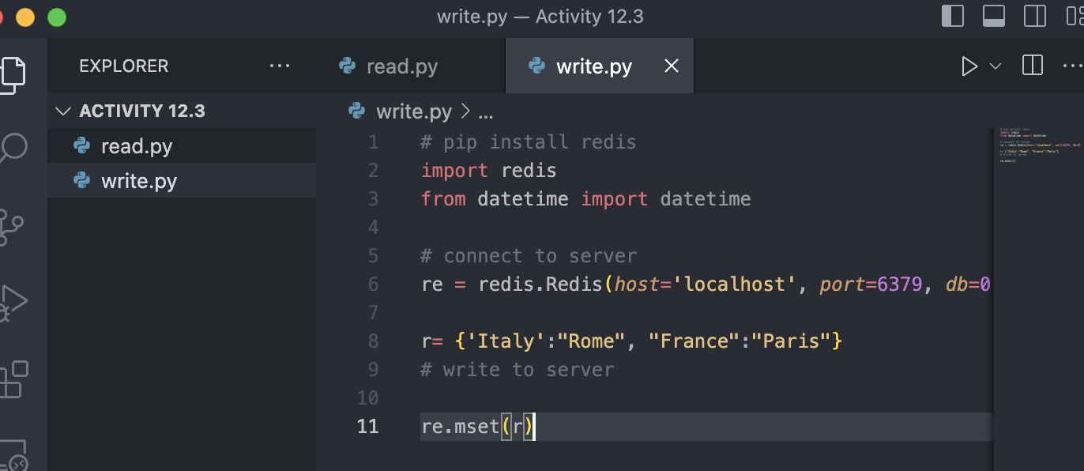
   1. Screenshot of adding dictionary mset with keys and values provided.
4. Text

   Description automatically generated
   1. I was successfully able to run write.py with no errors
5. Text

   Description automatically generated
   1. Screenshot of code for reading entries in dictionary r.
6. Text

   Description automatically generated
   1. Successfully printed the values.